Real-Time Network Intrusion Detection System

1. PROBLEM STATEMENT:
“To implement effective Real-Time Network Intrusion Detection System to reduce False alarm rate and improve efficiency, using machine learning technique.”

- REAL-TIME NETWORK INTRUSION DETECTION SYSTEM:
- Provides a wall of defense to confront the attacks of computer systems on Internet.
- Collects information from a network analyzes the information for symptoms of system breaches.
- Monitors network data and gives an alarm signal, when detects antagonistic activity on an open port.

- FALSE ALARM RATE:
- Anomaly detection system has the potential to generate too many false alarms.
- 4 quadrants based on the result obtained by the NIDS:
True Positive: attack data detected as attack data.
True Negative: normal data detected as normal data.
False Positive: normal data is detected as attack data.
False Negative: attack data is detected as normal data.

- MACHINE LEARNING ALGORITHMS:
- Used for classifying incoming network data into normal data and attack.
- E.g.
- Decision Tree
- Ripper Rule
- Back-Propagation Neural Network
- Radial Basis Function Neural Network
- Bayesian Network
- Näive Bayesian Etc.
2.OBJECTIVES
- Online NIDS
- Obtain highest detection rate and reduce FAR
- Implement and analyze different machine learning based algorithms (based on information gain), identify efficient and optimum algorithm

3. PLATFORM CHOICE
- Python Language.
Objective
- Python is object-oriented
Structure supports such concepts as polymorphism, operation overloading, and multiple inheritance.

- It's free (open source)
- Source code is easily accessible
- Free doesn't mean unsupported! Online Python community is huge.

- It's portable
Python runs virtually every major platform used today

- It's easy to use
- Running Python.
In addition to being a programming language, Python is also an interpreter.
The interpreter reads other Python programs and commands, and executes them. Python programs are compiled automatically before being scanned into the interpreter.

4. LITERATURE SURVEY
A]STUDY OF IEEE PAPERS
The papers we studied were:
1) Practical real-time intrusion detection using machine learning approaches
Phurivit Sangkatsanee, Naruemon Wattanapongsakorn, Chalermpol Charnsripinyo

2) Real-time anomaly detection systems for Denial-of-Service attacks by weighted k-nearest-neighbor classifiers
Ming-Yang Su

3) Real-time Intrusion Detection and Classification
Phurivit Sangkatsanee1, Naruemon Wattanapongsakorn,* and Chalermpol Charnsripinyo2

B]PACKET SNIFFERS
A packet sniffer, sometimes referred to as a network monitor or network analyzer, can be used legitimately by a network or system administrator to monitor and troubleshoot network traffic. Using the information captured by the packet sniffer an administrator can identify erroneous packets and use the data to pinpoint bottlenecks and help maintain efficient network data transmission.
A packet sniffer can only capture packet information within a given subnet. So, its not possible for a malicious attacker to place a packet sniffer on their home ISP network and capture network traffic from inside your corporate network (although there are ways that exist to more or less "hijack" services running on your internal network to effectively perform packet sniffing from a remote location). In order to do so, the packet sniffer needs to be running on a computer that is inside the corporate network as well. However, if one machine on the internal network becomes compromised through a Trojan or other security breach, the intruder could run a packet sniffer from that machine and use the captured username and password information to compromise other machines on the network.

The Packet Sniffers available are:
For Windows:
  - Capsa Network Analyzer
  - Microsoft Network Monitor
  - Wireshark (formerly known as Ethereal)
For Unix:
  - dSniff
  - NarusInsight
  - Ngrep
  - snoop
  - tcpdump

C] ATTACKS
The following type of attacks can be found in a network on a large scale. The role of a network intrusion detection system is to detect such attacks and inform the network administrator about it.
1. DoS
2. Probe
3. R2L
4.U2R

D] TOOLS FOR GENERATION OF ATTACKS
The attacks that we studied will have to be practically implemented to be able to study the characteristics well and also to train our IDS against such attacks in future.
The tools for generation of these attacks are as listed below:
(DoS attacks)
- LOIC
- Commands at the command prompt
(Probe attacks)
- IP Sweep
- PortSweep

E] MACHINE LEARNING

Machine learning is a branch of AI for scientific design and improvement of algorithms
- i/pàempirical data
- o/pàpatterns/features of the underlying mechanism that generated the data

- Approaches
  - Decision tree learning
  - Association rule learning
  - Artificial neural networks
  - Genetic programming
  - Inductive logic programming
  - Support vector machines
  - Clustering
  - Bayesian networks
  - Reinforcement learning
  - Representation learning
  - Sparse Dictionary Learning

5. DIAGRAMS

5.1 CLASS DIAGRAM
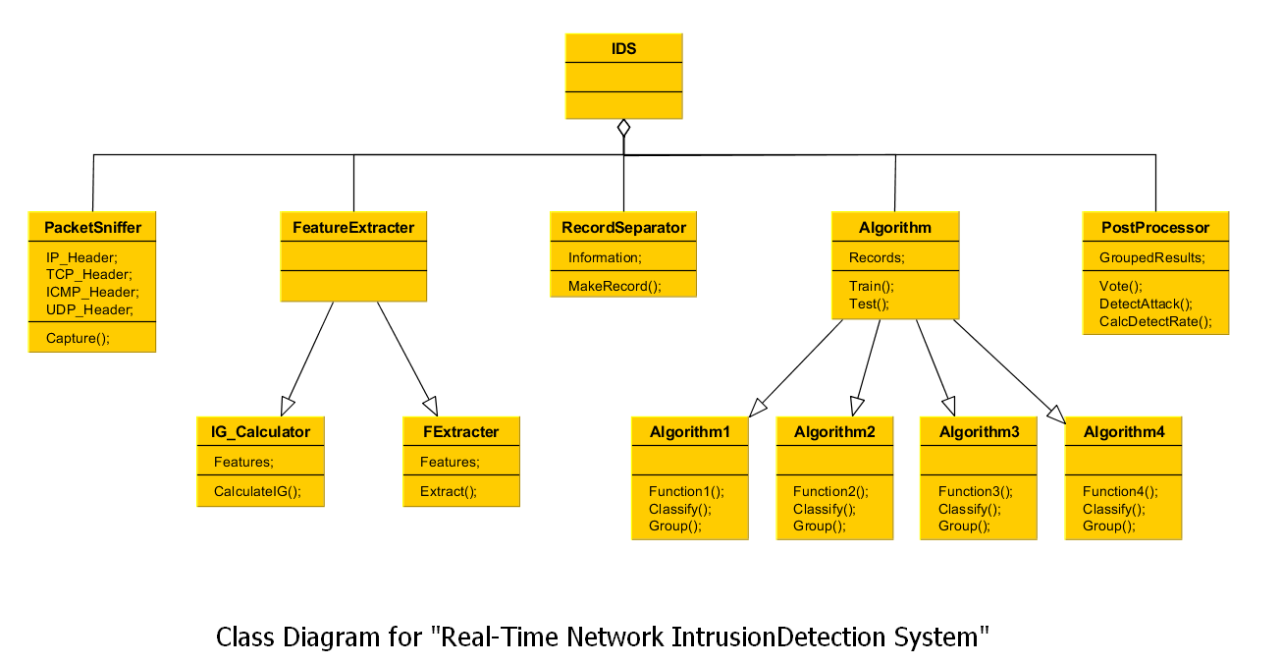

5.2 DATA FLOW DIAGRAM
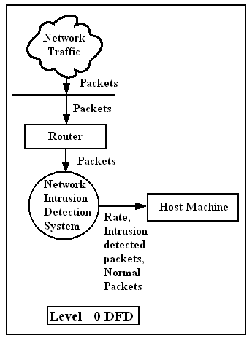

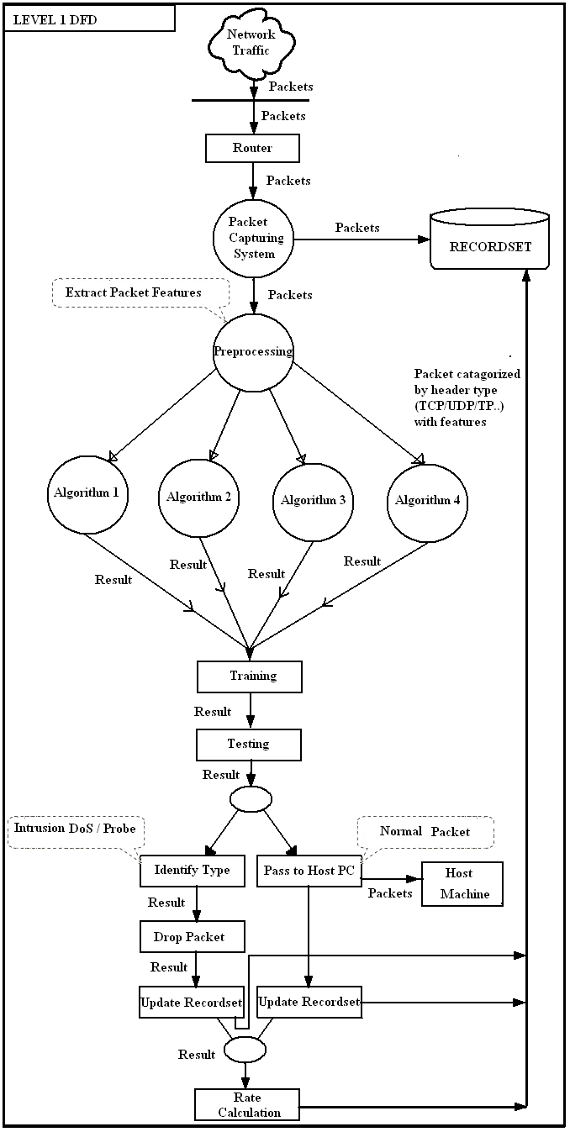
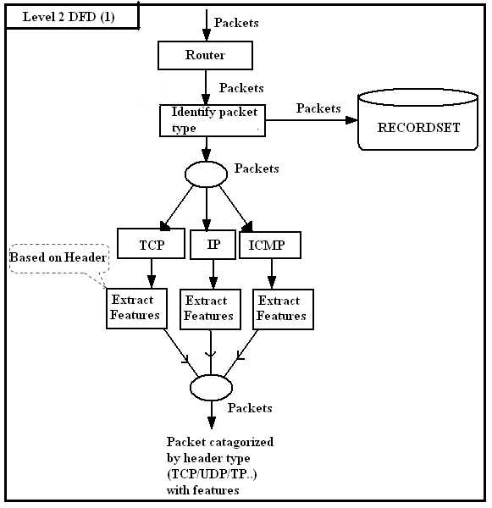

5.3 ER DIAGRAM

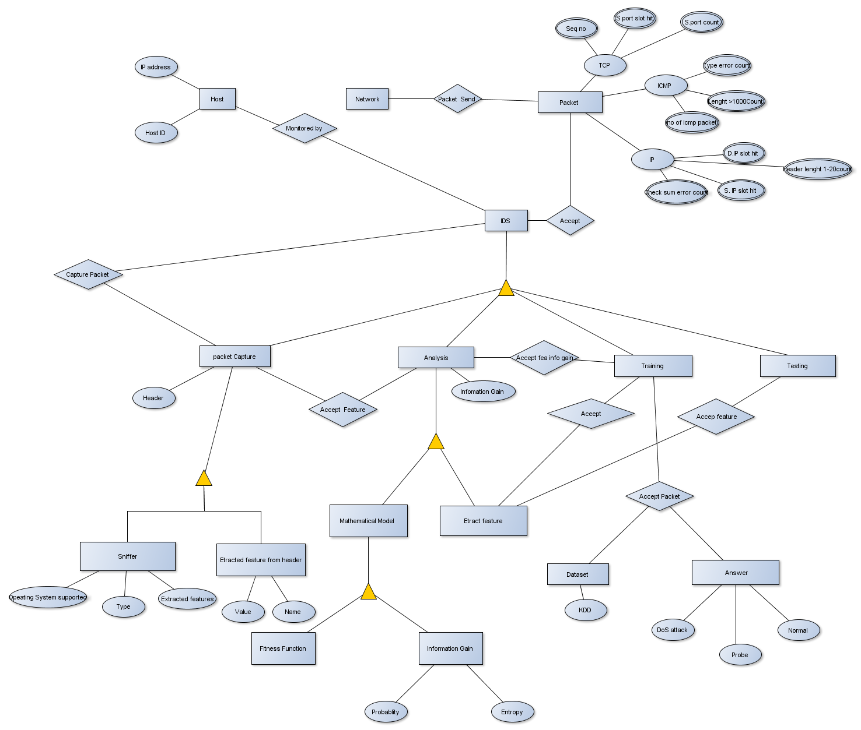

5.4 SYSTEM IMPLEMENTATION PLAN

No. | Schedule | PLANNED DURATION | ACTUAL DURATION
1. | Searching and Selection of Topic | 06/06/2012  TO  20/06/2012 | 06/06/2012  TO  25/06/2012
2. | Problem Definition | 21/06/2012  TO  22/06/2012 | 24/06/2012  TO  26/06/2012
3. | Literature Survey | 23/06/2012  TO  30/06/2012 | 26/06/2012  TO  02/07/2012
4. | Technical Study | 01/07/2012  TO  30/08/2012 | 03/07/2012  TO  04/09/2012
5. | Project Plan | 01/09/2012  TO  05/09/2012 | 05/09/2012  TO  07/09/2012
6. | Requirement Analysis | 09/09/2012  TO  20/09/2012 | //2012  TO  //2012
7. | Coding and Implementation | 21/09/2012  TO  13/02/2012 | //2012  TO  //2012
8. | Testing | 21/10/2012  TO  28/02/2012 | //2012  TO  //2012
9. | Modifications | 26/01/2012  TO  20/03/2012 | //2012  TO  //2012
10. | Project Completion and Report | 20/04/2012  TO  30/04/2012 | //2012  TO  //2012

